**SKU CODE: LMPK40B**

**Magic Pond Light 40 LED – Blue Plastic Housing 10m cable + Tx**

**SKU CODE: LMPK40W**

**Magic Pond Light 40 LED – White Plastic Housing 10m cable + Tx**

**Product specifications:**

|  |
| --- |
| With 40 pcs of super-bright LED |
| Size: 78mm x 70 mm |
| Power: AC12V500mA |
| Housing Material: Plastic |
| Cable length: 10 m (32 Feet) |
| Colour: Blue, White |

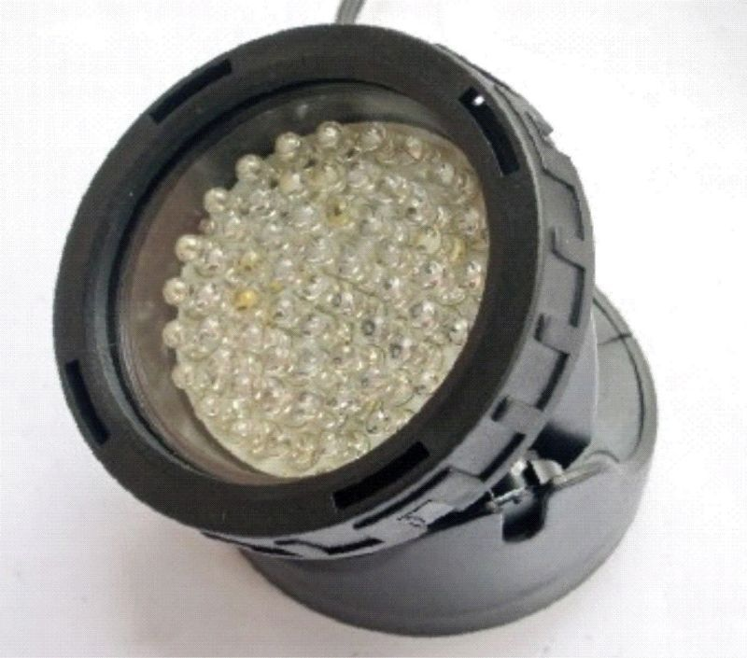

**SKU CODE: LMPK40WS3**

**Magic Pond Light 40 LED White** **Set 3 10m cable with Transformer**

**Product specifications:**

|  |
| --- |
| 3pcs QL 34 in series |
| Size: 78mm x 70mm |
| Power: AC12V 1000mA |
| Housing material: Plastic |
| Cable length: 10m |

